Bacani, Micah Angelo R.

2018 – 01602

Activity 1

**Pulling an image**

1. 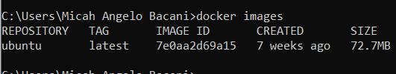Docker image
2. 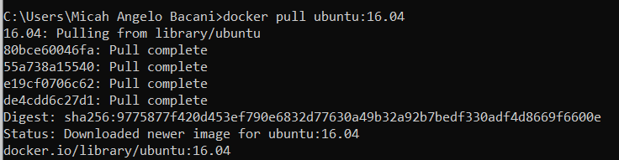Ubuntu 16.04
3. 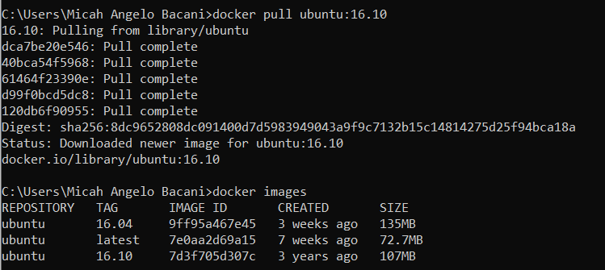Ubuntu 16.10
4. 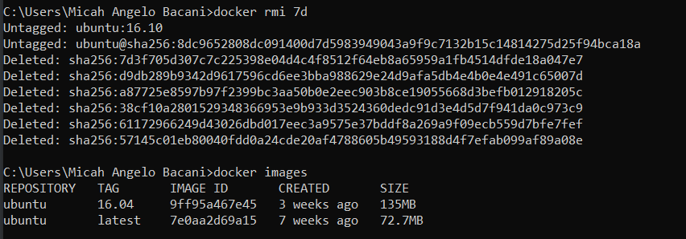Remove docker image

**Running the container**

1. Docker run echo
2. Checking containers
3. 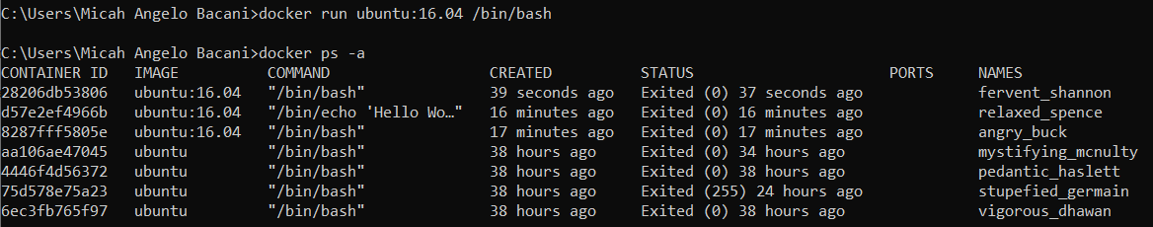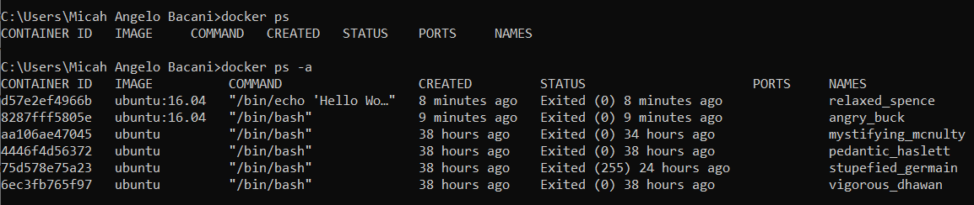Running bash

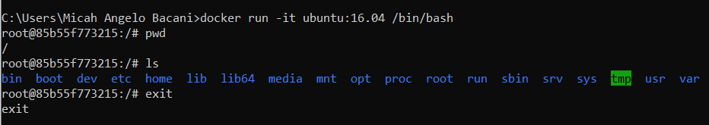

1. 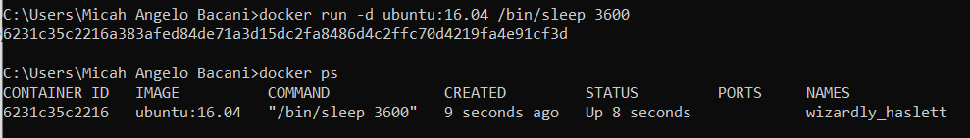Running detached mode
2. 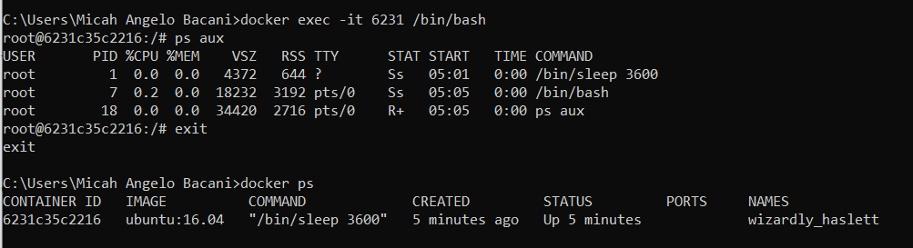Re-attach running container
3. 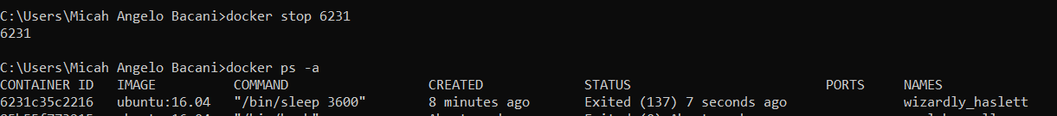Stop/kill
4. 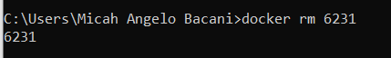Removing old containers

* 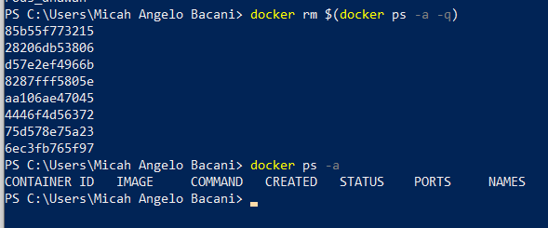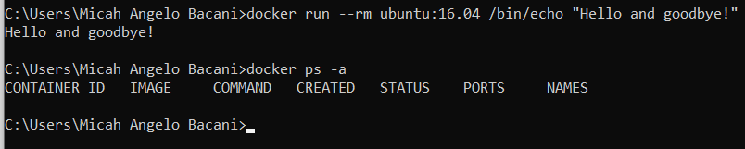The command `docker rm $(docker ps -a -q)` to remove all containers didn’t work on cmd so I had to do it on the windows PowerShell for it to work